Activity No 3.Finance Club Event “The Penny Pivot”

Title of the Event | Finance Club Event “The Penny Pivot” | 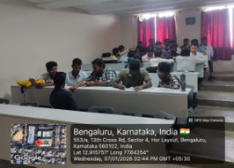
Day and Date | 07.01.26
Venue (With all details ) | Roon No-309
In collaboration with ( if any) | -
Details of Resource Person With Designation | Asst.Prof. Ritu U | 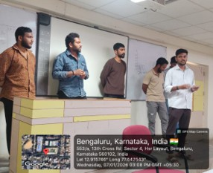
Organizing Department/Coordinators | Business Management . Asst.Prof. Ritu U
Course and semester | MBA I Semester
No of Students & Faculty Participants | 44

Coordinator HoD Vice-Principal Principal

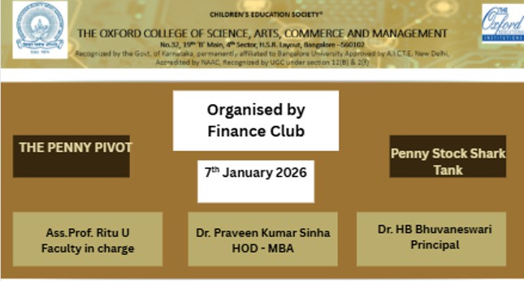

Introduction
The Penny Stock Shark Tank was an interactive financial simulation designed to move beyond traditional investing theory. Unlike a standard "Shark Tank" where participants pitch new ideas, this activity focused on corporate turnaround strategies. Participants were challenged to act as "Turnaround Specialists," analyzing failing Indian companies (Penny Stocks) and proposing strategic financial interventions to restore profitability and market value.

Description of the Activity

The Penny Stock Shark Tank was an interactive financial simulation designed to move beyond traditional investing theory. Unlike a standard "Shark Tank" where participants pitch new ideas, this activity focused on corporate turnaround strategies. Participants were challenged to act as "Turnaround Specialists," analyzing failing Indian companies (Penny Stocks) and proposing strategic financial interventions to restore profitability and market value.

Outcome of the Activity
The Penny Stock Shark Tank was an interactive financial simulation designed to move beyond traditional investing theory. Unlike a standard "Shark Tank" where participants pitch new ideas, this activity focused on corporate turnaround strategies. Participants were challenged to act as "Turnaround Specialists," analyzing failing Indian companies (Penny Stocks) and proposing strategic financial interventions to restore profitability and market value.

Conclusion
The Penny Stock Shark Tank was an interactive financial simulation designed to move beyond traditional investing theory. Unlike a standard "Shark Tank" where participants pitch new ideas, this activity focused on corporate turnaround strategies. Participants were challenged to act as "Turnaround Specialists," analyzing failing Indian companies (Penny Stocks) and proposing strategic financial interventions to restore profitability and market value.

